# *Technical Requirements Specification Document*

# *PRJ666 – Team No: 3*

# *Project:  FunNstay*

Team Members:

1. Harsh Kamleshbhai Parikh
2. Shaily Shah
3. Jilesh Sanjaykumar Patel

***Document Authors: -***

Harsh Kamleshbhai Parikh

Shaily Shah

Jilesh Sanjaykumar Patel

The Purpose of this document is to make a record of the points that we worked or will be working to build the app are as follows:

1. Objective: The Main Objective of this application is to offer a wide range of benefits for guests and hotels. For guests, it will provide a convenient and time-saving check-in process, along with giving them a choice to select the rooms and amenities that they want along with the options to change the reservations before time if they want. On the other hand, for hotel/staff it will reduce the waiting times and long queues and any type of misunderstanding regarding the bookings. Moreover, this application enhances data accuracy and security, while integration with existing hotel management systems will further optimize operations.
2. Target Audience: The target Audience for this applications are the guests that will use this app to book any rooms with different amenities as per their choice and can also use some of the vouchers or coupons to get good discount while checking out. It also targets the hotel staff to have a smooth process of check in process and to manage the availability of rooms or the changes that have been made. They can also get the details of the guest and contact then in any case
3. Scope: The scope of the application is to make an ecofriendly and user-friendly applications that is useful for all it contains some of the key features like:
4. Digital Registration Forms: The application will replace traditional paper forms with digital registration forms that guests can complete using their smartphones or tablets. This eliminates the need for manual data entry and reduces errors.
5. Identity Verification: The application will integrate identity verification mechanisms, such as ID scanning or facial recognition, to ensure the accuracy and security of guest information.
6. Room Selection and Upgrades: Guests will have the option to select their preferred room type to include the views and explore available upgradable amenities that will enhance their overall experience.
7. Mobile Cancellation: When a guest wish to cancel the booked room, upgrade their amenities, and more services, The system will send them the notification of any changes with updated pricing that were done by them with a confirmation message.
8. Payment Integration: The application will integrate with various payment gateways, enabling guests to settle their bills securely through the app.
9. Benefits: The Benefit of building this app is to provide user/guest wide range of options to choose room with different views and amenities as per their choice and they have opportunity to cancel the reservation with some restrictions. Also, this innovative solution will empower hotels to provide exceptional service, elevated guest satisfaction, and remain competitive in the dynamic hospitality industry.
10. Business Goals: One of the primary goals is to encourage guests to book their hotel stays directly through the application rather than relying on third-party booking platforms. This app can also lead to increase customer loyalty and positive word-of-mouth recommendations. The application can contribute to optimizing the hotel's occupancy rates by effectively managing room availability and maximizing booking opportunities. The system can provide real-time updates on room availability, enable dynamic pricing strategies, and offer personalized promotions to fill vacant rooms and minimize revenue loss.
11. Constraints or Limitations Time constraints and the need for rapid development may limit the initial feature set, requiring a phased approach for functionality implementation. Technical limitations and potential dependencies on external APIs or services may impact the integration capabilities and overall scalability of the application.
12. Success Criteria: Increases direct bookings, resulting in a measurable percentage shift from third-party platforms to the application as the primary booking channel. Also, improves guest satisfaction, evidence by positive ratings and feedback, with a target increase in overall guest experience scores by a specified percentage.

# 2 - Project Overview

The hotel registration application will leverage technology to replace traditional paper-based registration forms with a user-friendly application, allowing guests to complete the check-in process conveniently and securely. The hospitality industry has witnessed significant technological advancements in recent years, revolutionizing various aspects of hotel operations. However, the traditional hotel check-in process still largely relies on manual paperwork, leading to inefficiencies, long waiting times, and diminished guest satisfaction. Recognizing this opportunity for improvement, our team has developed a overview for the hotel registration application, aiming to transform the way hotels handle check-ins. with the increasing reliance on smartphones and the growing preference for digital solutions, the hotel registration app offers a modern and convenient alternative to the cumbersome paper-based check-in procedures. By leveraging mobile technology and intuitive user interfaces, the app performs registration process, providing guests with a seamless experience. Through extensive market research and feedback from hotel guests and industry professionals, we will identify the points that associates with traditional check-ins, including lengthy queues, manual data entry errors, and the need for physical keys or key cards. Our hotel registration app will address head-on, streamlining the process, enhancing data accuracy, and improving overall operational efficiency.

The app offers features to guests to minimize physical contact during check-in while maintaining a high level of security and convenience. We believe that our hotel registration application will have the potential to revolutionize the check-in experience for both guests and hotel staff. By embracing this innovative solution, hotels will enhance guest satisfaction, optimize operational efficiency, and position themselves as industry leaders in a highly competitive market.

Problem Statement

|  |  |
| --- | --- |
| The Problem of: | The problem of inefficient and time-consuming hotel reservation processes |
| Affects: | It affects both hotel guests and staff, resulting in a cumbersome and frustrating experience. The stakeholders affected by this problem include potential guests, hotel front desk personnel, reservation agents, and management. |
| The impact of which is: | The impact of this problem is a significant loss of time and effort for guests who face difficulties in searching for available rooms, making reservations, and managing bookings. It also leads to increased workload for hotel staff, decreased operational efficiency, and potential loss of business opportunities due to manual errors or delays. |
| A successful solution would: | A successful solution would streamline the reservation process, offering a user-friendly platform that allows guests to easily search for available rooms, make reservations, modify bookings, and receive prompt confirmation. This solution would significantly improve the guest experience, enhance operational efficiency for hotel staff, reduce errors, and increase revenue through seamless online bookings. |

Product Vision

|  |  |
| --- | --- |
| For | hotel guests and staff who seek a seamless and efficient reservation experience |
| Who | Who face challenges in navigating complex booking processes and managing reservations, |
| The Product Name | Is a Hotel Reservation Management Software. |
| That | That provides a user-friendly interface, real-time availability updates, and personalized services, |
| Unlike | Unlike traditional booking platforms or manual reservation systems, |
| Our product | Our product offers a streamlined interface, intuitive navigation, and seamless integration with hotel systems, Enabling guests to easily find and book accommodations, and empowering staff with efficient reservation management tools. |

*Design Specifications.*

*Note :- this designs are not the final ones, but yes they will be similar.*

*Architecture Diagrams*

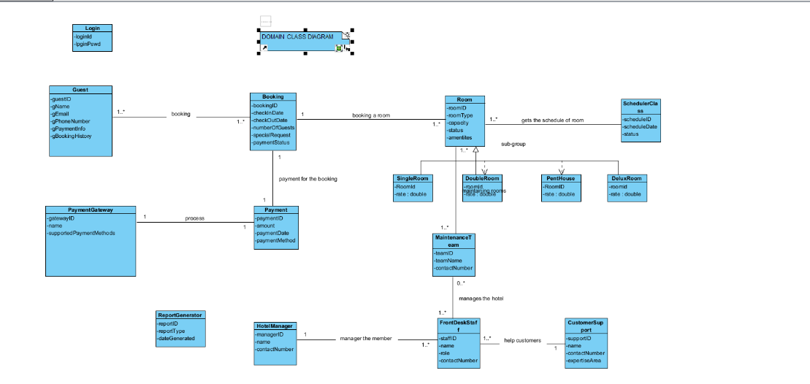

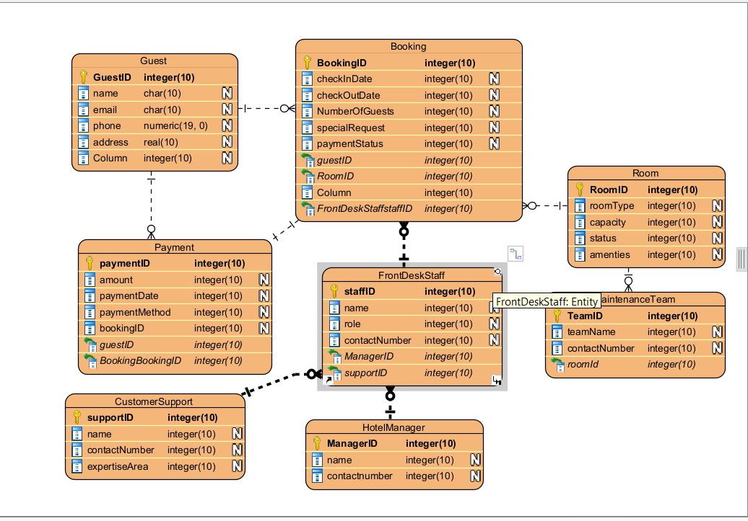

DATA DICTIONARY

|  |  |  |  |  |  |
| --- | --- | --- | --- | --- | --- |
| Entity | Attribute Name | DAta Type | Descritption | Constraints | Related Entity/foreign Key |
| Guest | GuestID (pk) | Integer | Unique identifier | Unique, Not null |  |
| Guest | Name | Text | Name | Not Null |  |
| Guest | Email | Text | Email Address | Vaild email format |  |
| Guest | Phone | Text | Phone Number | Specific format |  |
| Guest | Address | Text | Address | Not Null |  |
|  |  |  |  |  |  |
|  |  |  |  |  |  |